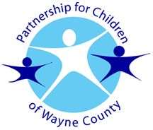
The Partnership for Children of Wayne County

800 N. William St., Goldsboro, NC 27530 Phone: 919 735-3371
FAX: 919 735 3194 Email: info@pfcw.org Website: www.pfcw.org

Child’s name:

INCOME STATEMENT

I, , am not currently receiving income from employment. I am currently unemployed.

I do receive $ per week / month. This income is from the following source: (child support, etc.) and is correct for the month(s) of .

My signature below verifies that this information is accurate. I understand that deliberate misrepresentation of the information may subject me to prosecution under applicable federal and/or state laws.

Signature Date

