Smart Start Categories for Evidence Based and Evidence Informed Activities
EB/EI Category | Icon | Definition | Key Features
Evidence-Based:  Well-established |  | Programs and practices that have strong evidence of their effectiveness across multiple studies. Generally a systematic review or meta-analysis was conducted that included studies with experimental or quasi-experimental designs. | Systematic review or meta-analysis with experimental or quasi-experimental designs
Evidence-Based: Established | 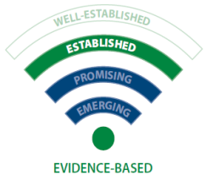 | Programs and practices that had at least three studies using an experimental or quasi-experimental design that found evidence of their effectiveness. | 3 studies with experimental or quasi-experimental designs
Evidence-Informed: Promising | 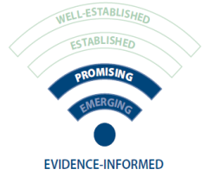 | Evidence-informed programs and practices that had at least one study that compared the effectiveness of the intervention for people who participated in the program and those who did not participate. The level of evidence suggests the intervention would qualify as evidence-informed as long as a strong logic model and “written” guidelines exist. | At least one study with comparison group
Evidence-Informed: Emerging | 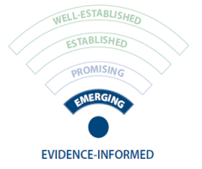 | Evidence-informed programs and practices that had only preliminary data with no comparison group. The level of evidence suggests the intervention would qualify as evidence-informed as long as a strong logic model and “written” guidelines exist. | Preliminary results with no comparison group
The following are the definitions that were passed by the NCPC Board in 2011:
- Evidence-based programs or practices are those that have repeatedly and consistently demonstrated desirable outcomes through application of scientific research methods (replicated experimental, experimental, or quasi experimental.)

- An evidence-informed practice is one that is guided by child development theory, practitioner wisdom, qualitative studies and findings from basic research and has written guidelines, a strong logic model, and a history of demonstrating positive results. They may be rated “Promising” or “Emerging” by at least one source that rates evidence-based programs.

